*Time series* – A time series is a set of data points ordered in time. The data is equally spaced in time, meaning that it was recorded at every hour, minute, month, or quarter. Typical examples of time series include the closing value of a stock, a household’s electricity consumption, or the temperature outside.

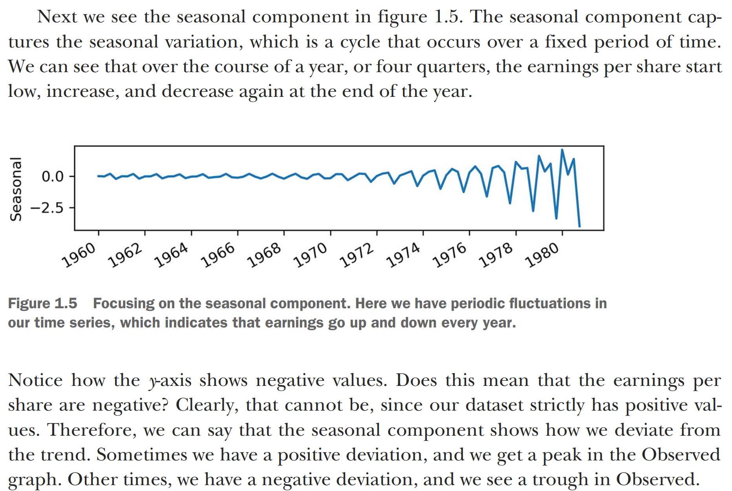

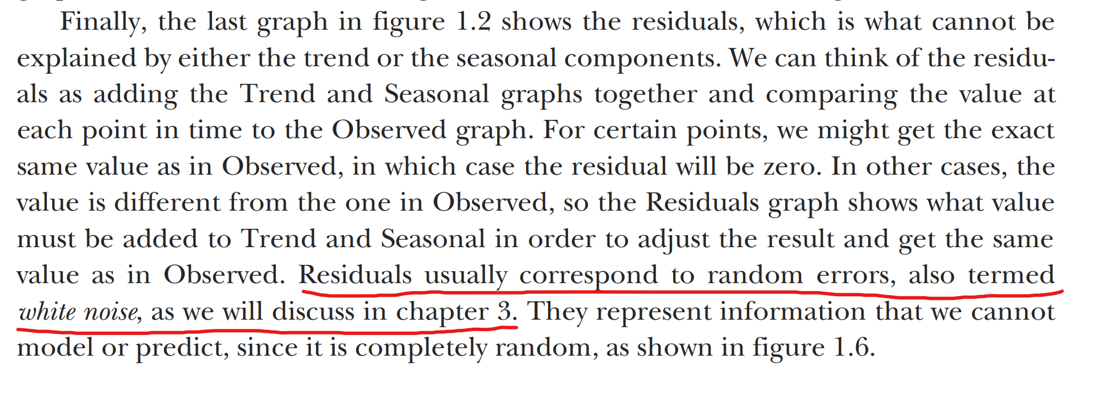

*Time series decomposition* – Time series decomposition is a process by which we separate a time series into its components: trend, seasonality, and residuals. The trend represents the slow-moving changes in a time series. It is responsible for making the series gradually increase or decrease over time. The seasonality component represents the seasonal pattern in the series. The cycles occur repeatedly over a fixed period of time. The residuals represent the behavior that cannot be explained by the trend and seasonality components. They correspond to random errors, also termed white noise.